BookFlow Project Structure
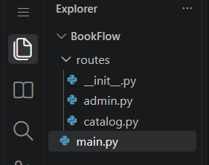
routes/catalog.py
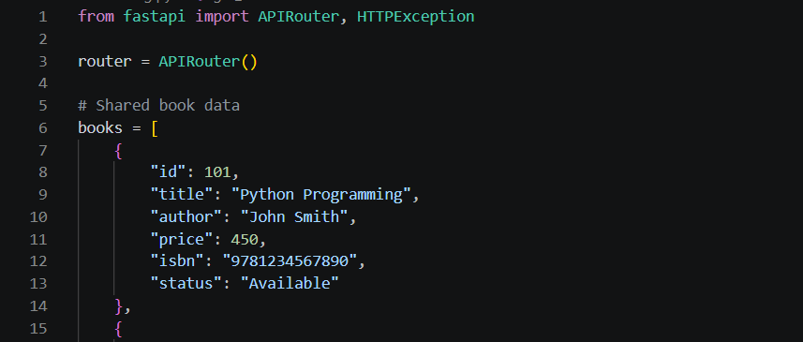
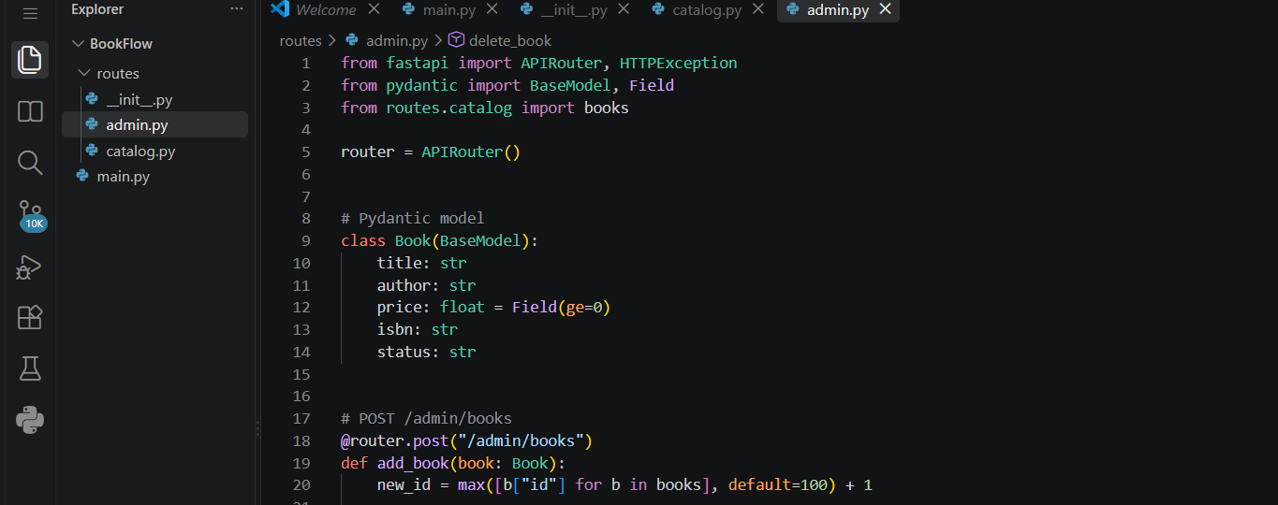
Main.py
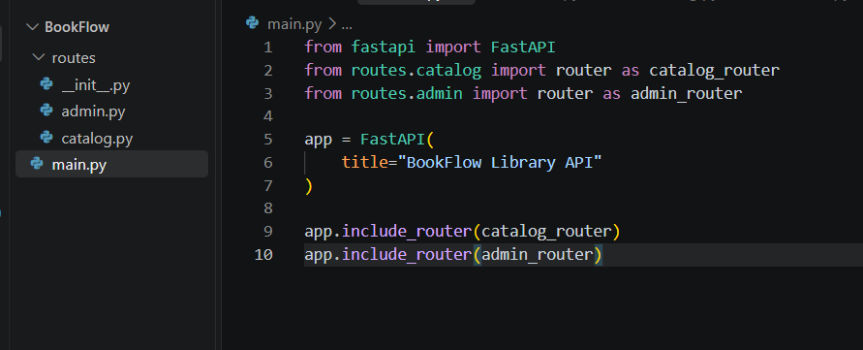
FastAPI Application
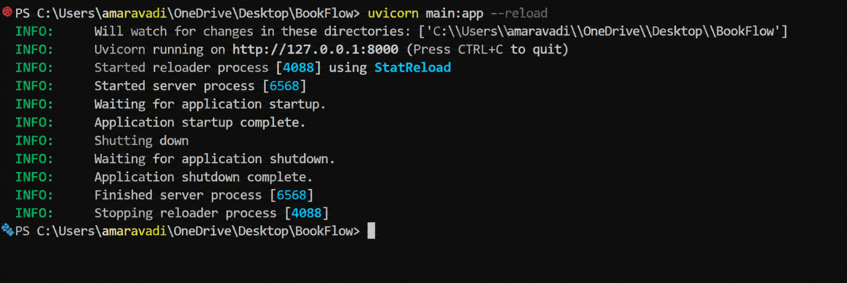
Open Swagger UI
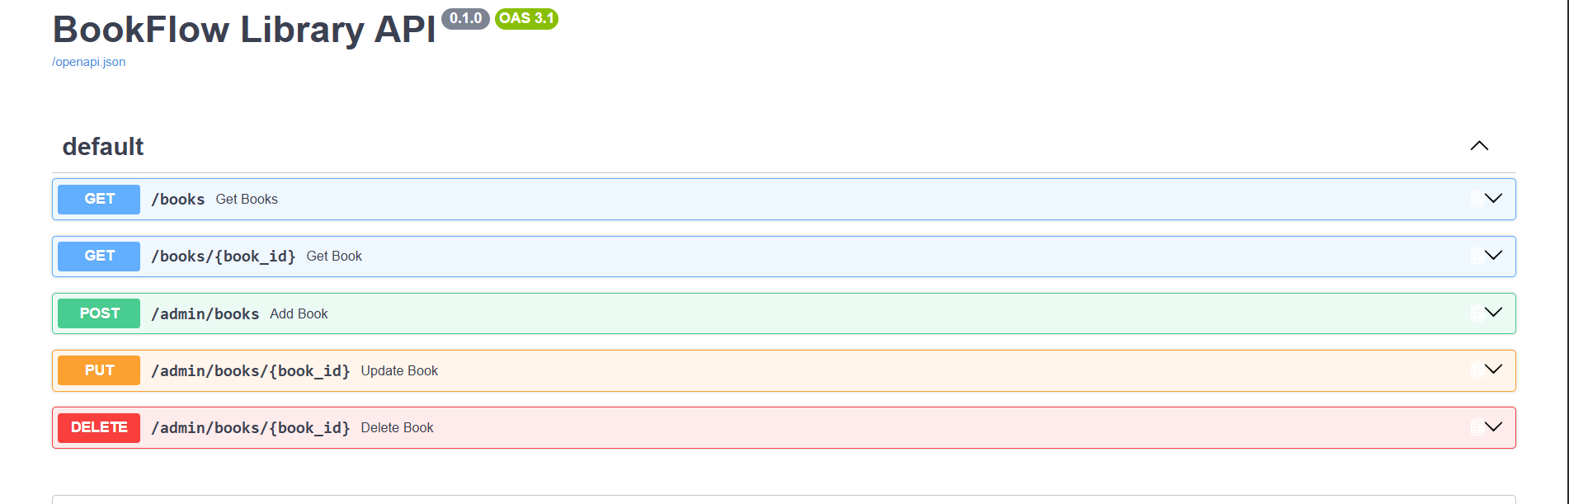
Test GET /books
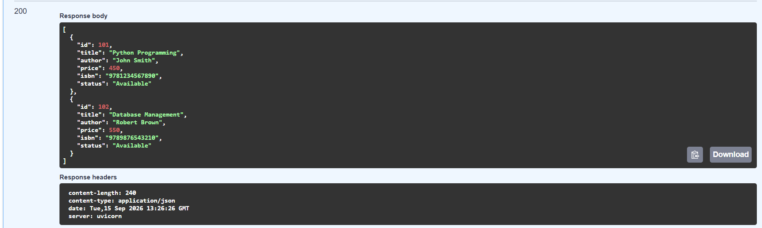
Test POST /admin/books
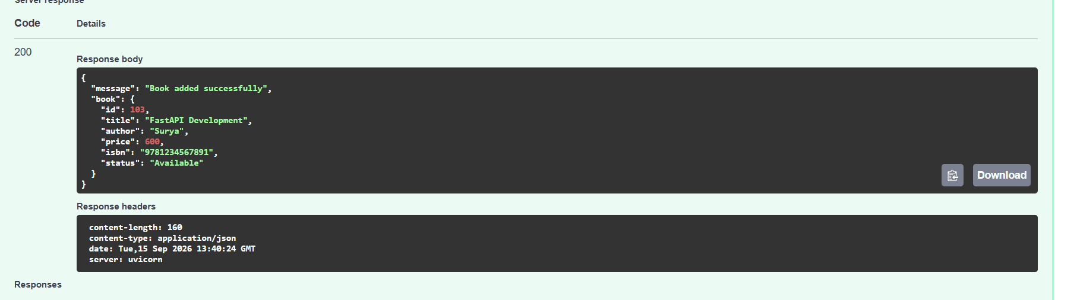
PUT /admin/books/{book_id}
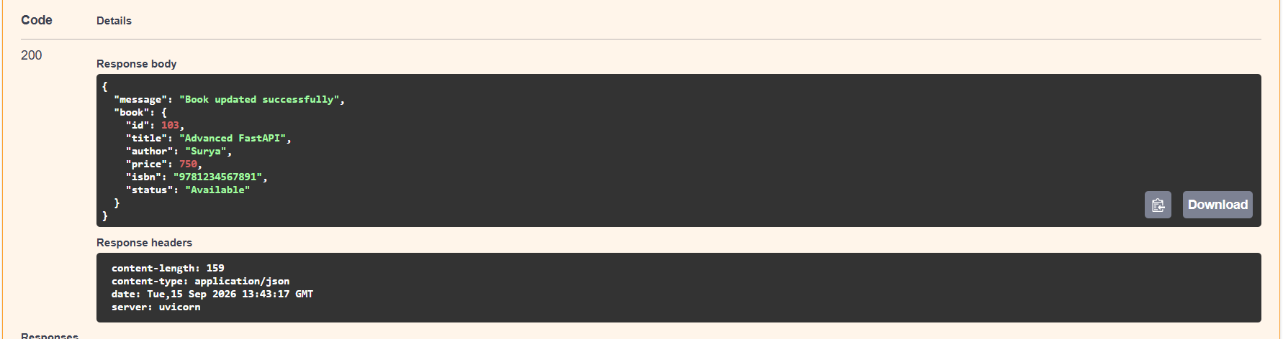
DELETE /admin/books/{book_id}
